Testing course

Software testing is verifying and validating whether the system is meeting the expectations of the organization or not
Uses:
- Best QQuality product
- Time saving
- Business optimization
- User Experience and CSAT
Principles of Software Testing:
- Detecting Bugs
- Early Testing for reducing error costs
- Defect Clustering
- Context Dependent
Software Testing Life Cycle:
- Requirement Analysis – what needs to be tested ( functional & non functional )
- Test Planning – Everything test process ( no of ppl, no of hours)
- Test Case Development – step by step procedure how test should be executed
- Environment setup – setup of software and hardware
- Test execution – Executing the code and comparing actual and expected
- Test cycle closure – meeting team member and evaluating the cycle completion
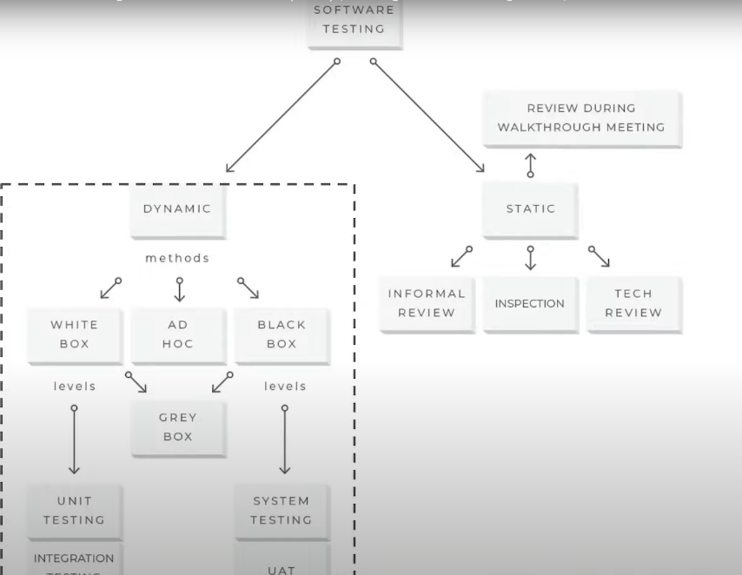

Static Testing : informl form of testing
Dynamic Testing: actual software is tested here
There are different types:
- Black Box: Inputs and outputs are checked, whether app is functioning crct or not
- White Box: It involves testing some structural part of the code
- Grey Box: Mix of both
Ad-HOC Testing: Informal testing where no documentation, no test plan

Levels of Software Testing:
- Unit Testing: micro level, individual units are tested
- Integration testing: Individual units are integrated and then tested whether they are functioning correct
- System Testing: Testing the whole integrated system
- Acceptance Testing(UAT ) : Testing the final system

Types:
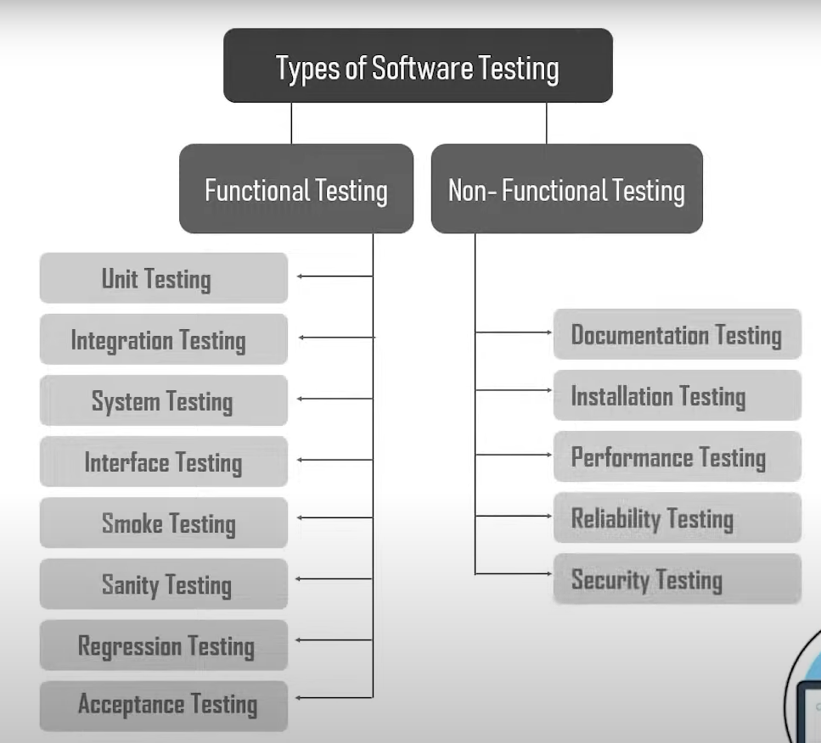
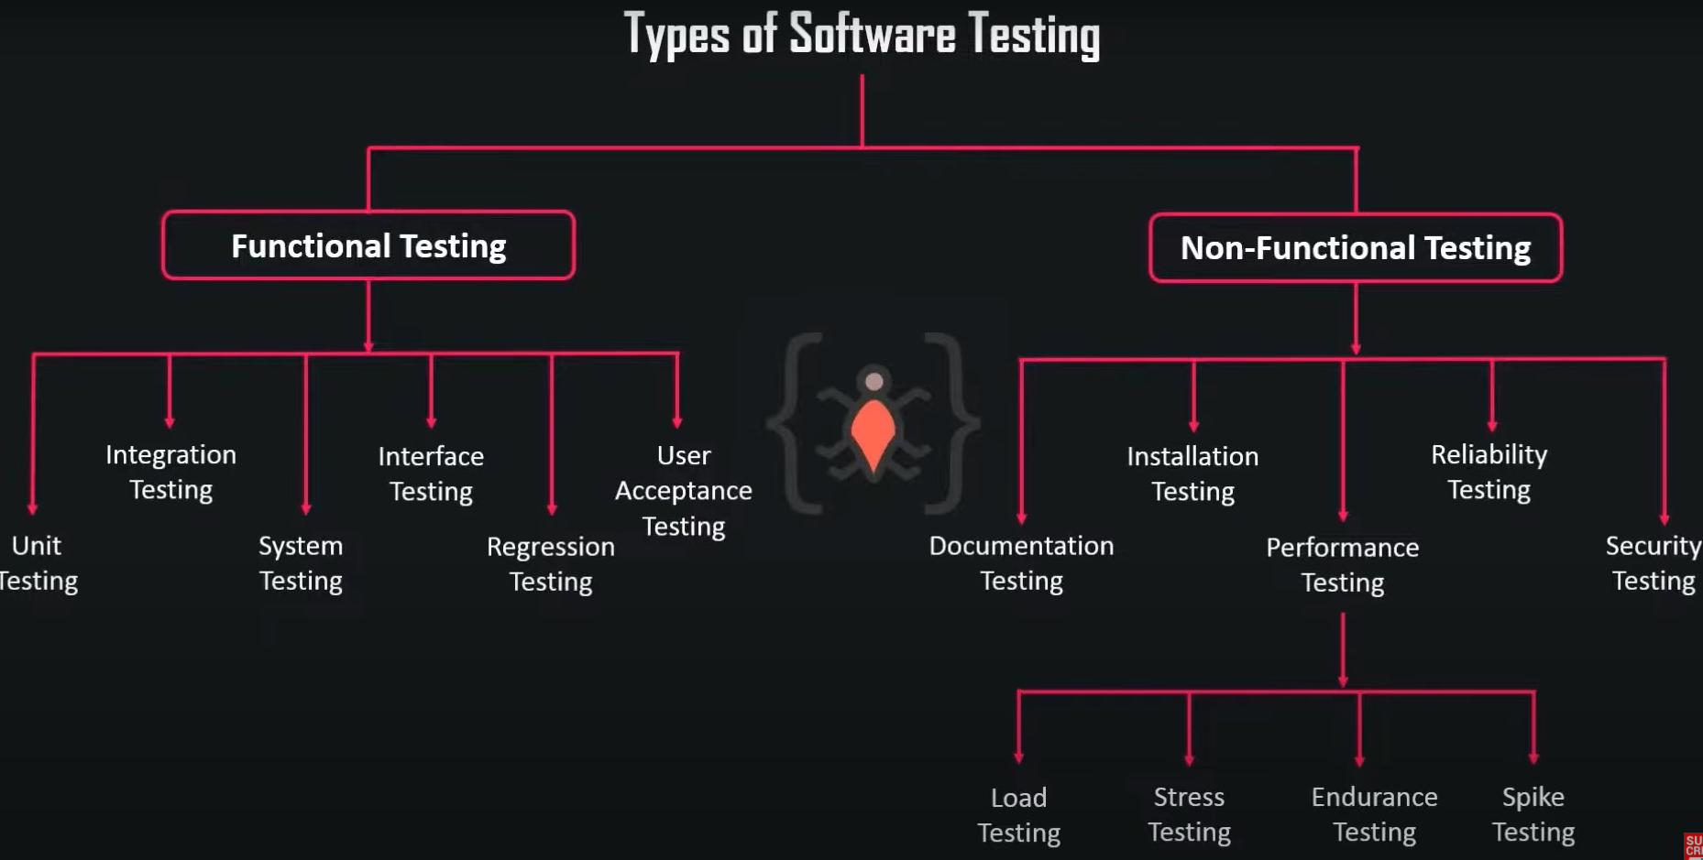

UNIT TESTING TASKS:
1. Unit test plan
2. Unit test cases
3. Unit test
Integration Testing:
Approaches: Big Bang ( All system ), Top Down( Top level first next low level ), Bottom up, hybrid
System Testing:
Manufactured separately, Unit tested , Integrated then tested, System testing is done
Interface Testing:
It verifies the communication between the components. It has 3 phases:
1. Configuration
2. Validation
3.Maintainance
Usage:
It is required to check if server Is working fine. Error Handling is checked and security aspects are inspected
Regression Testing:
To identify the stability of product with changing requirements
Techniques:
1.Retest all
2.Regressinon test selection
3. Test cases are prioritized based high, med, low
4. Hybrid

Acceptance Testing:
User Acceptance Testing: Product is working crct/mot for user usage
Business Acceptance:
Contract Acceptance
Operational Acceptance
Alpha: used by testers/developers
Beta: real world ppl uses

Performance Testing:
Types :
Load Testing: Increased load then tested
Stress Testing : Beyond the work load
Endurance Testing: continuous load giving
Spike testing: sudden load

Reliability Testing: Assures the product is fault free and reliable
Types:
Feature Testing:
Regression testing: When a feature is removed , testing whether functionality is fine
Load: Finding the break point through increasing load

Sandbox testing:
Sandbox testing is a software testing method where new or untested code is executed in an isolated environment (sandbox) that mimics the real system but is separate from the production environment.
Types of Sandbox Environments
- Development Sandbox
  - Used by developers to write and test code independently.
  - Each developer may have their own sandbox.
  - Example: A local IDE connected to a dummy database.
- Testing/QA Sandbox
  - Used by QA/testers to run unit tests, integration tests, and regression tests.
  - Typically mirrors the production environment but with test data.
- UAT (User Acceptance Testing) Sandbox
  - Shared with end users or clients for validating business requirements.
  - Example: A sandbox where a business team tests if workflows match their needs.
- Staging Sandbox
  - Very close to production, used for final pre-release checks.
  - Ensures that deployment will work exactly the same way in production.
- Security Sandbox
  - Used in cybersecurity to safely run untrusted code, files, or malware.
  - Often set up in a virtual machine (VM) or isolated container.
- API/Service Sandbox
  - Provided by third-party services (e.g., PayPal, Stripe, AWS) to let developers test API calls with dummy data.
  - Prevents misuse of live data during testing.

Software Testing Methodologies:
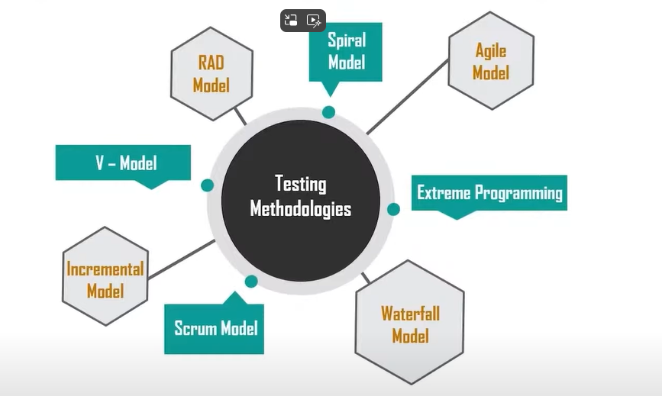

Water Fall model:
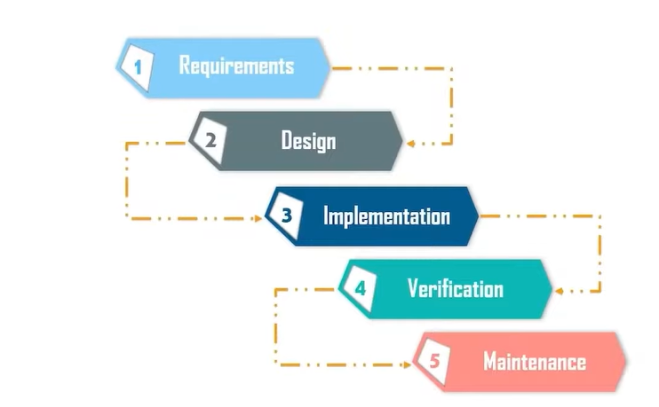

V-Model:
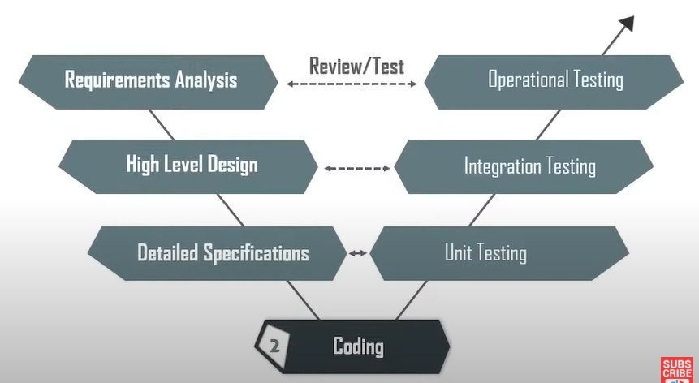
Incremental Model:
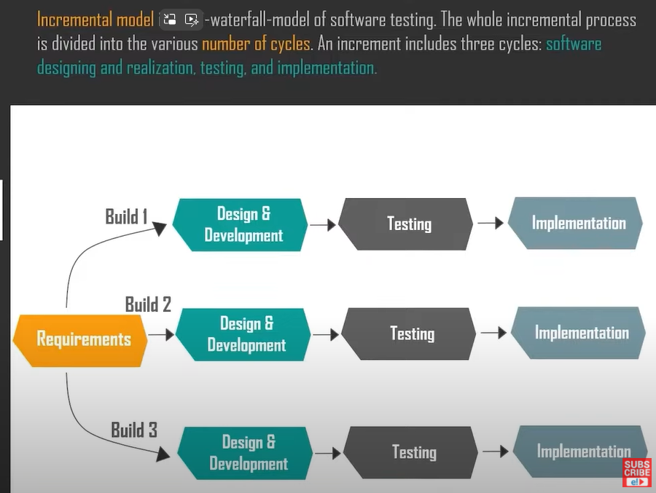

Agile Model:
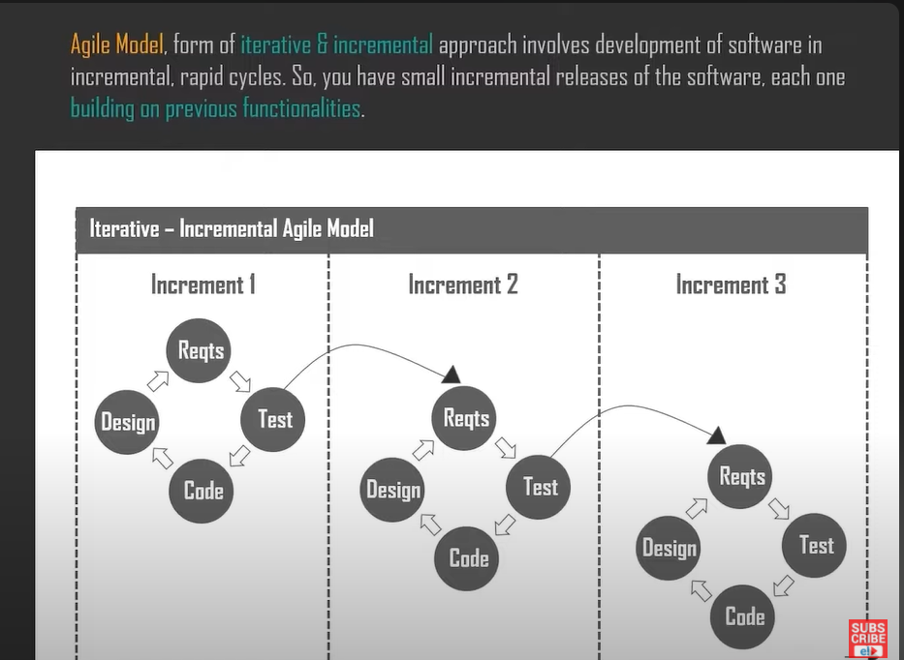

SPIRAL MODEL
RAD MODEL

SOFTWARE TESTING TECHNIQUES
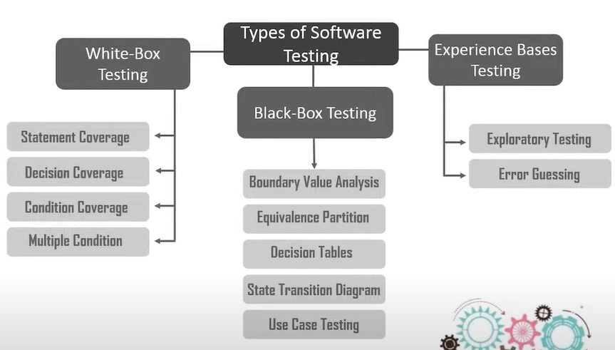

Black box testing techniques:

Equivalance partitioning:
The inputs are divided into equal parts which comes under the same category and then tested such that the time and resources are saved
Boundary value:
Usually errors occur at the boundaries rather than normal areas. So it checks at the boundaries like (At boundary , Values below boundaries, values above boundaries)
Decision Tables:
We take the conditions that are tested and also the possibilities like that we draw a table and find out the output
State Transition Diagram:
It is used when the system is giving different outputs to the same inputs.
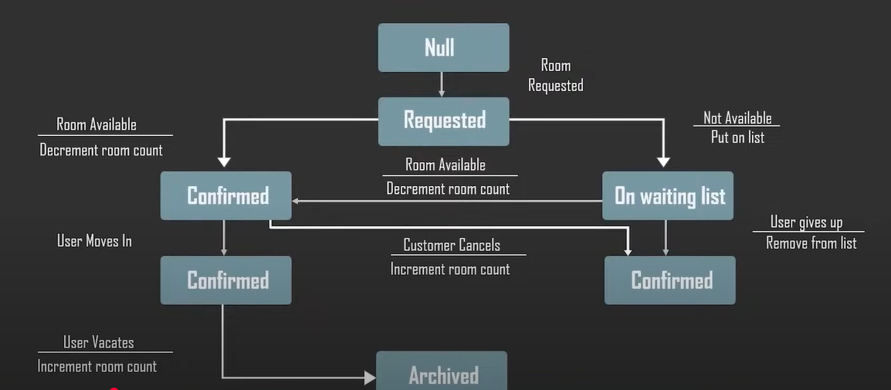
Use Case Testing:
It is a functional testing technique, identify scenarios with each scenario having a test case and a condition.

WHITE BOX TESTING TECHNIQUES:
Statement Coverage:
Every statement is executed at least once, it only takes care about the positive ones but doesn’t care about the negative one which is not mentioned there
Branch Coverage:
It checks all the branches of the code and make sure no branch is producing abnormal behaviour. It checks the condition provided and prints the output and for the opposite else condition if nothing is provided it says decision pending.
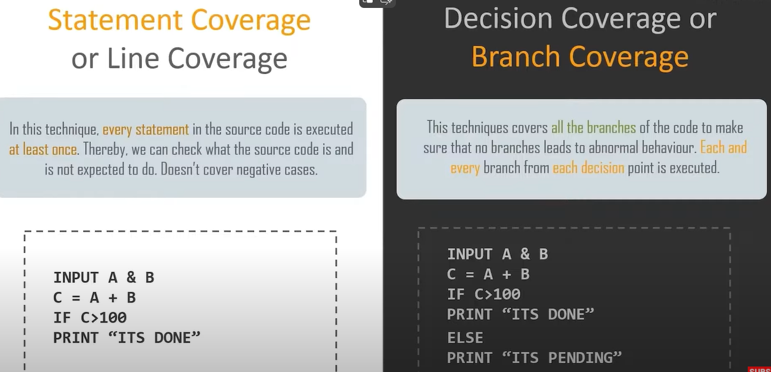

Condition Coverage:
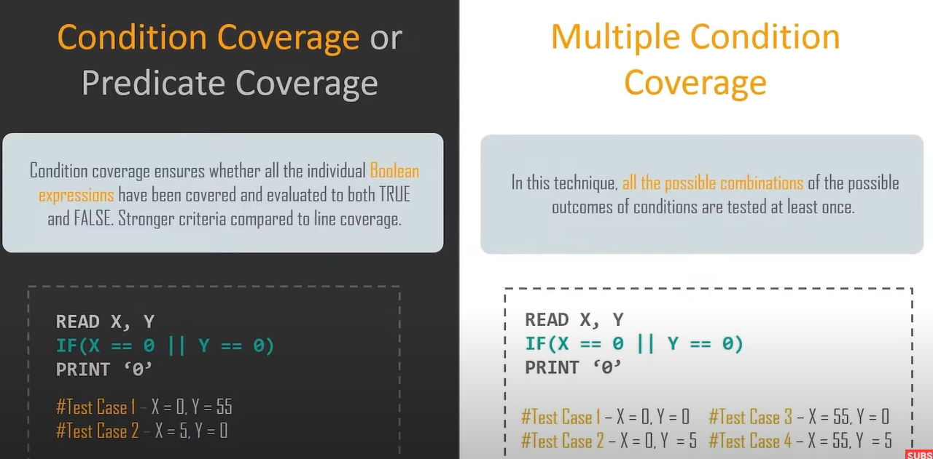
Writing a Test Case:
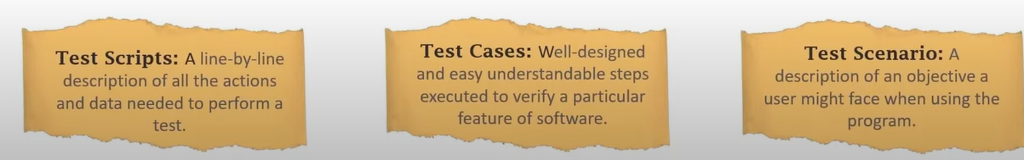
Test cases are used to verify whether the system is working as per the end user requirement or not…whether the feature is producing any bugs or not
The tester has to think in multiple angles in which the user might get issue and try to verify that such that the end user doesn’t get any issue while using.
Test Case Format:

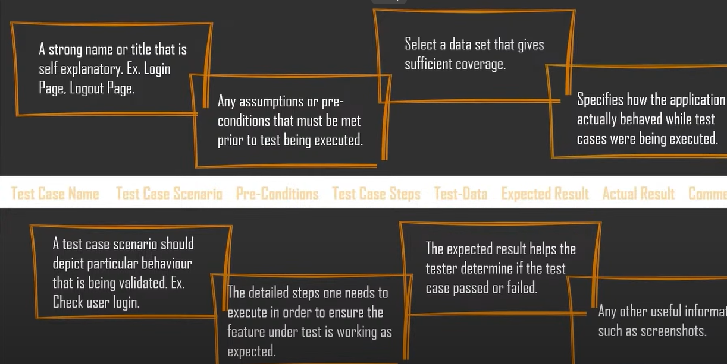

Sanity Testing:
When new changes are made to the code, Sanity Testing is used to test the software build after making the changes to the code and verifying whether they’re fixed or not
It also helps to ensure that changes doesn’t effect existing functionalities
How to do:
It is a quick process to test, no need to script
- Identification of new bugs
- Evaluate the identified features and functionalities (proper working )
- Testing all the parameters, functionalities

Smoke Test:
It is done after the initial build to check whether all the critical functionalities are working fine or not.
